[](https://www.genmymodel.com/)

# ExamOnlineAcase

Online exam Activity

Author: PrashantVishwakarma

Date: 2022-09-26

# ExamOnlineAcase (Model)

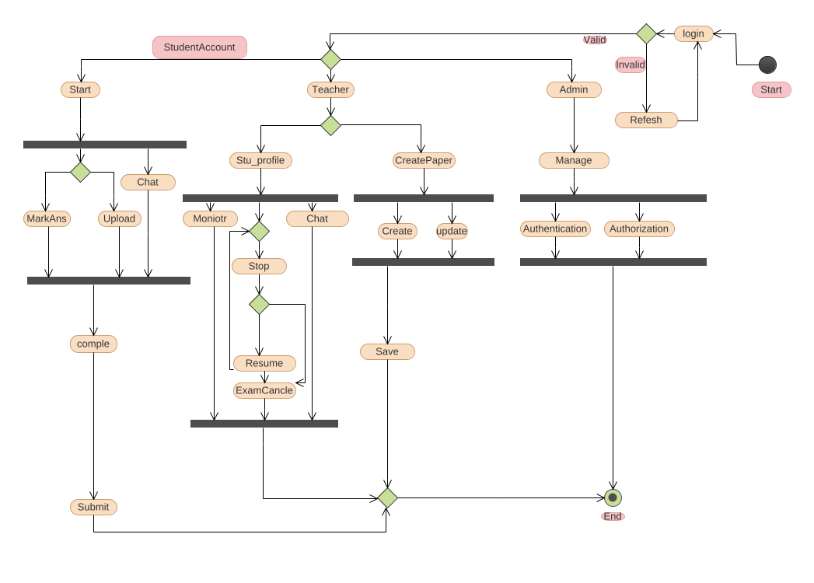

activity-diagram

## 1. Activity (Activity)

In ExamOnlineAcase

### 1.1. (DecisionNode)

In ExamOnlineAcase::Activity

### 1.2. ActivityFinalNode (ActivityFinalNode)

In ExamOnlineAcase::Activity

### 1.3. ActivityFinalNode2 (ActivityFinalNode)

In ExamOnlineAcase::Activity

### 1.4. Admin (OpaqueAction)

In ExamOnlineAcase::Activity

### 1.5. Authentication (OpaqueAction)

In ExamOnlineAcase::Activity

### 1.6. Authorization (OpaqueAction)

In ExamOnlineAcase::Activity

### 1.7. CentralBufferNode (CentralBufferNode)

In ExamOnlineAcase::Activity

### 1.8. Chat (OpaqueAction)

In ExamOnlineAcase::Activity

### 1.9. Chat (OpaqueAction)

In ExamOnlineAcase::Activity

### 1.10. Create (OpaqueAction)

In ExamOnlineAcase::Activity

### 1.11. CreatePaper (OpaqueAction)

In ExamOnlineAcase::Activity

### 1.12. DecisionNode (DecisionNode)

In ExamOnlineAcase::Activity

### 1.13. DecisionNode10 (DecisionNode)

In ExamOnlineAcase::Activity

### 1.14. DecisionNode11 (DecisionNode)

In ExamOnlineAcase::Activity

### 1.15. DecisionNode12 (DecisionNode)

In ExamOnlineAcase::Activity

### 1.16. DecisionNode13 (DecisionNode)

In ExamOnlineAcase::Activity

### 1.17. DecisionNode14 (DecisionNode)

In ExamOnlineAcase::Activity

### 1.18. DecisionNode2 (DecisionNode)

In ExamOnlineAcase::Activity

### 1.19. DecisionNode3 (DecisionNode)

In ExamOnlineAcase::Activity

### 1.20. DecisionNode4 (DecisionNode)

In ExamOnlineAcase::Activity

### 1.21. DecisionNode5 (DecisionNode)

In ExamOnlineAcase::Activity

### 1.22. DecisionNode6 (DecisionNode)

In ExamOnlineAcase::Activity

### 1.23. DecisionNode7 (DecisionNode)

In ExamOnlineAcase::Activity

### 1.24. DecisionNode8 (DecisionNode)

In ExamOnlineAcase::Activity

### 1.25. DecisionNode9 (DecisionNode)

In ExamOnlineAcase::Activity

### 1.26. End (SendSignalAction)

In ExamOnlineAcase::Activity

### 1.27. ExamCancle (OpaqueAction)

In ExamOnlineAcase::Activity

### 1.28. ForkNode (ForkNode)

In ExamOnlineAcase::Activity

### 1.29. ForkNode2 (ForkNode)

In ExamOnlineAcase::Activity

### 1.30. ForkNode3 (ForkNode)

In ExamOnlineAcase::Activity

### 1.31. ForkNode4 (ForkNode)

In ExamOnlineAcase::Activity

### 1.32. ForkNode5 (ForkNode)

In ExamOnlineAcase::Activity

### 1.33. ForkNode6 (ForkNode)

In ExamOnlineAcase::Activity

### 1.34. ForkNode7 (ForkNode)

In ExamOnlineAcase::Activity

### 1.35. InitialNode (InitialNode)

In ExamOnlineAcase::Activity

### 1.36. InitialNode2 (InitialNode)

In ExamOnlineAcase::Activity

### 1.37. Invalid (SendSignalAction)

In ExamOnlineAcase::Activity

### 1.38. JoinNode (JoinNode)

In ExamOnlineAcase::Activity

### 1.39. JoinNode2 (JoinNode)

In ExamOnlineAcase::Activity

### 1.40. JoinNode3 (JoinNode)

In ExamOnlineAcase::Activity

### 1.41. JoinNode4 (JoinNode)

In ExamOnlineAcase::Activity

### 1.42. JoinNode5 (JoinNode)

In ExamOnlineAcase::Activity

### 1.43. JoinNode6 (JoinNode)

In ExamOnlineAcase::Activity

### 1.44. JoinNode7 (JoinNode)

In ExamOnlineAcase::Activity

### 1.45. Manage (OpaqueAction)

In ExamOnlineAcase::Activity

### 1.46. Manage (OpaqueAction)

In ExamOnlineAcase::Activity

### 1.47. MarkAns (OpaqueAction)

In ExamOnlineAcase::Activity

### 1.48. MergeNode (MergeNode)

In ExamOnlineAcase::Activity

### 1.49. MergeNode2 (MergeNode)

In ExamOnlineAcase::Activity

### 1.50. MergeNode3 (MergeNode)

In ExamOnlineAcase::Activity

### 1.51. MergeNode4 (MergeNode)

In ExamOnlineAcase::Activity

### 1.52. MergeNode5 (MergeNode)

In ExamOnlineAcase::Activity

### 1.53. MergeNode6 (MergeNode)

In ExamOnlineAcase::Activity

### 1.54. MergeNode7 (MergeNode)

In ExamOnlineAcase::Activity

### 1.55. Moniotr (OpaqueAction)

In ExamOnlineAcase::Activity

### 1.56. OpaqueAction (OpaqueAction)

In ExamOnlineAcase::Activity

### 1.57. Parameter (ActivityParameterNode)

In ExamOnlineAcase::Activity

### 1.58. Refesh (OpaqueAction)

In ExamOnlineAcase::Activity

### 1.59. Resume (OpaqueAction)

In ExamOnlineAcase::Activity

### 1.60. S.profilr (JoinNode)

In ExamOnlineAcase::Activity

### 1.61. Save (OpaqueAction)

In ExamOnlineAcase::Activity

### 1.62. Start (OpaqueAction)

In ExamOnlineAcase::Activity

### 1.63. Start (SendSignalAction)

In ExamOnlineAcase::Activity

### 1.64. Start (SendSignalAction)

In ExamOnlineAcase::Activity

### 1.65. Stop (OpaqueAction)

In ExamOnlineAcase::Activity

### 1.66. Stu_profile (OpaqueAction)

In ExamOnlineAcase::Activity

### 1.67. StudentAccount (SendSignalAction)

In ExamOnlineAcase::Activity

### 1.68. Submit (OpaqueAction)

In ExamOnlineAcase::Activity

### 1.69. Submit (OpaqueAction)

In ExamOnlineAcase::Activity

### 1.70. Teacher (OpaqueAction)

In ExamOnlineAcase::Activity

### 1.71. Upload (OpaqueAction)

In ExamOnlineAcase::Activity

### 1.72. Valid (SendSignalAction)

In ExamOnlineAcase::Activity

### 1.73. comple (OpaqueAction)

In ExamOnlineAcase::Activity

### 1.74. login (OpaqueAction)

In ExamOnlineAcase::Activity

### 1.75. student (OpaqueAction)

In ExamOnlineAcase::Activity

### 1.76. update (OpaqueAction)

In ExamOnlineAcase::Activity